Watchlater.yaml

This Maestro scenario extends the previous one by adding steps to verify that a podcast is in the "Watch Later" list, open the podcast details from the "Watch Later" list, mark the podcast as watched, and then verify that the podcast is marked as watched.

This sequence of steps taps on an element with the text "Watch Later," asserts the visibility of the "Your Watch Later List," and then asserts the visibility of an element with the text "Exciting Podcast" in the "Watch Later" list.

1)Verify the Podcast in Watch Later List

2) Open Podcast Details from Watch Later List

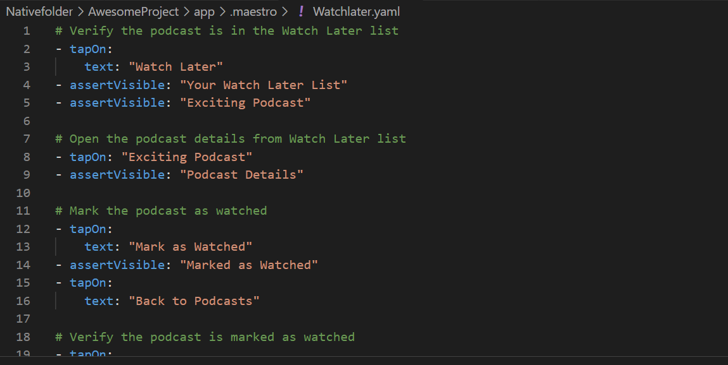

3)Mark the Podcast as Watched

4) Verify Podcast Marked as Watched

In these steps, the scenario taps on "Watch Later," asserts the visibility of "Your Watch Later List," and then asserts that the "Exciting Podcast" is not visible. This assumes that the podcast is no longer visible in the "Watch Later" list after being marked as watched.

Favorite.yaml

# flow: run the login flow and then navigate to the demo podcast list screen, favorite a podcast, and then switch the list to only be favorites.

Here, environment variables (TITLE and FAVORITES_TEXT) are defined, likely for reuse within the scenario steps. These variables seem to store text values.

yamlCopy code

- runFlow: Login.yaml

This step executes another scenario (Login.yaml) that likely simulates the login flow. The details of this login flow are specified in the separate Login.yaml file.

yamlCopy code

- tapOn: "Podcast" - assertVisible: "React Native Radio episodes"

After the login flow, the scenario taps on an element with the text "Podcast" and asserts that the text "React Native Radio episodes" is visible.

The scenario interacts with an element with the text specified in the FAVORITES_TEXT variable. It taps on it, asserts the visibility of "This looks a bit empty," and taps on it again. The retryTapIfNoChange option is set to false to avoid issues related to accidental double-tap on Android.

Finally, the scenario scrolls until an element with the text specified in the FAVORITES_TEXT variable is visible, taps on it, and asserts the visibility of an element with the text specified in the TITLE variable.

Output of test-:

